**Perkins**

**4301 College Ave., Des Moines IA. 50311**

**Phone 242-8430 Fax: 274-1367**

**Principal: Mr. Koss**

**School Hours-8:45 AM to 3:30 PM**

|  |  |  |
| --- | --- | --- |
| **C** = Conferences | **E** = Early Dismissal-1:45 | **OH** = Open House |
| **CP** = Class Party | **L** = Last Day | **PTA** = PTA |
| **D** = Noon Dismissal | **N** = No School | **R** = Relays |
| **PA** = Parade | **W** = Walk-A-Thon | **F** = First Day |
| **P** = Picture | **CA** = Carnival | **LT=PTLC Meetings** |
| **S2 =** Begin 2nd Semester |  |  |

|  |  |  |
| --- | --- | --- |
| **C** = Conferences | **E** = Early Dismissal-1:45 | **OH** = Open House |
| **CP** = Class Party | **L** = Last Day | **PTA** = PTA |
| **D** = Noon Dismissal | **N** = No School | **R** = Relays |
| **PA** = Parade | **W** = Walk-A-Thon | **F** = First Day |
| **P** = Picture | **CA** = Carnival | **LT=PTLC Meetings** |
| **S2 =** Begin 2nd Semester |  |  |

**Perkins**

**4301 College Ave., Des Moines IA. 50311**

**Phone 242-8430 Fax: 274-1367**

**Principal: Mr. Koss**

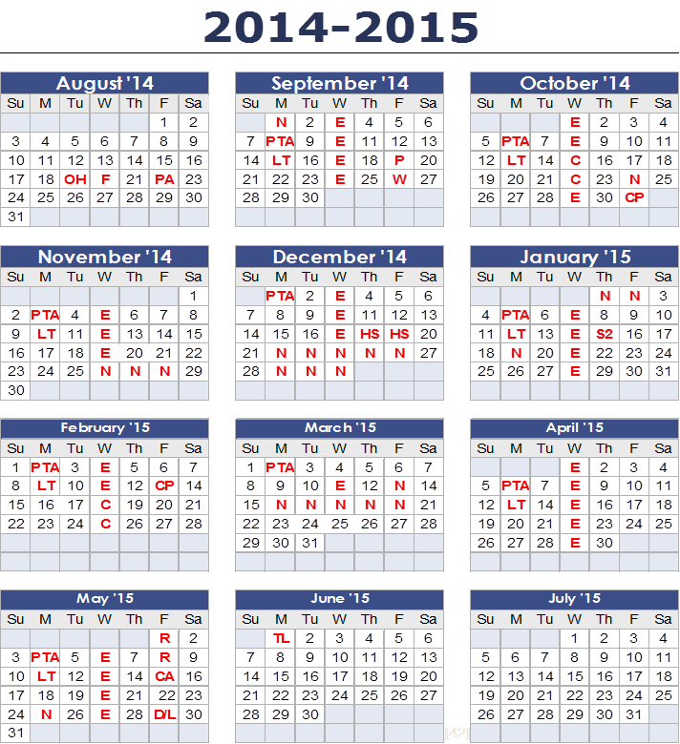**School Hours: 8:45 AM to 3:30**